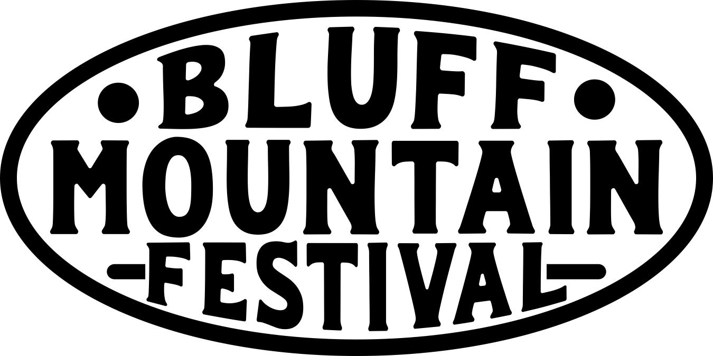
Saturday, June 13. 2026 10:00 am – 6:00 pm Presented by the Madison County Arts Council

Application and Contract
PLEASE TYPE OR PRINT CLEARLY:

Name___________________________________________E-mail______________________________

Company Name_______________________________ Website _______________________________

Address_____________________________________________________________________________

City ______________________________________________State _____ Zip _________________

Phone (____) ________________________ Emerg. No. (___) ___________________________

NC Sales Tax ID Number (required!!)______________________________________________________________

We will not process your application or assign a booth without an NC State Sales tax ID number.

Category/type of Work:
_______________________________________________________________________________________

All food sales will be done by designated food vendors. No food or drink allowed for sale in artist booths. Exceptions made for items like honey or jam, but no ready to eat stuff.

Application & booth fee: Current MCAC Member $35___ Non-member: $60____

For ease of festival setup, please return Application to MCAC office NO LATER THAN June 5th, 2026. Applications may be accepted up to the day of the festival if booth space is available, but booths reserved by June 5 will be guaranteed a space.

GENERAL RELEASE
The undersigned does hereby discharge, release and hold harmless, the Madison County Arts Council, all cities, property owners, and associations and all co-sponsors from any and all manner of action, damages, or claims whatsoever arising from any loss or damages or claims, to the person or property of the undersigned while in possession or under the supervision of the sponsors during the Festival, and hereby consents to enforcement of all rules of this event. Furthermore, the undersigned artisan hereby certifies that all display work is handcrafted and created by the seller. Participant understands that any mass-produced item on display can cause possible expulsion from the show. There are no rain dates.

MCAC RESERVES THE RIGHT TO DISQUALIFY ANY EXHIBITOR CAUSING ANY PROBLEMS TO FELLOW EXHIBITORS OR MANAGEMENT. Failure to comply with the rules and regulations of this General Release may result in expulsion from this event. Management reserves the right to make final interpretation of all rules.

If accepted, MCAC has my permission to reproduce my artwork, through the slides or photographs I have submitted, for the purpose of advertising and marketing the Festival. MCAC also has my permission to publish photographs or videos taken of me, my booth and my work during the Festival for purposes related to promotion of the Festival, past or future.

Signed ________________________________________________________Date___________________

EXHIBITOR RULES AND REGULATIONS

The committee of The Bluff Mountain Arts Festival and the Madison County Arts Council thanks you for your participation in our festival. In order for you to help us make our event the best it can be, we have established some guidelines. To participate in our events, you are required to observe the following rules and regulations . . . . . . . .

1) All work must be original, handcrafted, created and exhibited by the artist/s themselves. Kits, imports and mass-produced items are not acceptable. This rule is strictly enforced.

2) If your work is not known to the committee, your application must be accompanied by 3 photos of your work. Please email photos to madcoarts@gmail.com or include a print out with your application. You can send in application via email to the same email.

3) All categories shall be reviewed prior to acceptance. If your application is rejected, application fee will be returned.

4) The approved exhibitor/s will occupy his or her booth at all times. If you want to share booth space all artists work must go through the application process – note on your application form the artist with whom you will share space. NO FOOD OR DRINK SALES FROM ARTIST BOOTHS. Exceptions to this rule might be honey or JAM, but no ready to eat food or drink for sale from artist booths.

5) Each exhibitor is responsible for collecting the State Sales Tax and filing a report with the Department of Revenue.

6) Artists are responsible for their own tents, tables, chairs, displays, etc. Artist displays must be sufficiently sturdy to withstand weather and crowds. Each artist is responsible for his or her own display in case of loss or damage. If dollies are required for set up and tear down you must provide your own. MCAC will not be able to provide dollies, chairs, tents, displays, or tables. This is an outdoor event, which takes place rain or shine.

7) Displays must be professional and aesthetically pleasing. The object is to make your 10’ x 10’ space an art gallery. Exhibitors will leave their exhibit space clean after packing up on Saturday.

8) Exhibitors will receive an ample amount of booth space. Exhibitors will not take up any additional space without first consulting logistics coordinators. All work, display and storage will not go beyond the assigned area. Your booth should not interfere with your neighbor’s booth. Logistics coordinators shall make the final determination.

9) Booth numbers will be assigned by Wednesday, June 10th and vendors may do early set-up between 2-5 pm on Friday, June 12th. Set up on Saturday June 13th begins at 8:00am. The exhibitor’s space will be occupied by 9:30 a.m., and breakdown is not to begin until 5:00 p.m. An exhibitor will be considered a “no-show” and his or her space may be given away if not occupied by 9:30 a.m. Vehicles must be removed by 9:30 a.m., and there are no vehicles allowed in the area until 5:00 p.m. Tardy exhibitors may be excluded. Reminder – there is no security on site, so most folks who set up early just get the basic stuff set up as opposed to a full-on set up.

10) Park in designated Vendor area ONLY. Vendors may not park on site unless previous arrangements have been approved..

11) Set up and breakdown times will be strictly enforced. You must arrive by the specified time. Breakdown will not begin until the 5:00 p.m. Vehicles will not be permitted in the vendor area until this time. The event committee will have the final decision on this safety precaution.

12) Due to insurance liability, exhibitors are NOT allowed to bring pets or any animals to the show site.

13) If you have a problem at the show, you should communicate immediately to a member of the event committee or an MCAC staff member. You should not go to anyone involved with the property that is being used for the staging of the event. Get your problem solved immediately. We are here to make this a great day for everyone.

13) All rules will be strictly enforced. Failure to comply with rules or unruly behavior by the exhibitor or any assistants will cause immediate expulsion from the festival. Management reserves the right to make final interpretation of all rules. For more information call (828)649-1301. You can also email us at madcoarts@gmail.com
The Madison County Arts Council will not assume liability for any act of God, natural disaster, exposure to adverse weather conditions, damages, injuries or any legal authority, or any cause above and beyond the control of MCAC.
We appreciate everyone's cooperation and look forward to a very successful event- thanks to you. See you at the show! Return completed applications to madcoarts@gmail.com or:
Madison County Arts Council
P.O. Box 32 Marshall, NC 28753

